Introduction to Command Line

|  |
| --- |
| Welcome to the introduction to Command Line. As one of the previous lessons covered there is a GUI (graphical user interface) and a CLI (command line interface). This document will go over using the command line, as well as giving you exercises to familiarise yourself with it. The Ubuntu terminal will be the focus of this document but the concepts can be carried over to Windows Bash as well as other command lines. |

WHAT IS A COMMAND LINE?

A command line refers to the input method of commands to a computer. You might be used to using a graphical user interface but as a software developer you will need to know how to use a command line.

It allows us to input commands that would be difficult or tedious to do via the GUI. Commands such as running certain programmes or scripts, or even installing packages quickly.

So being comfortable with the CLI is important to work effectively and efficiently.

### WHAT CAN I DO WITH THE CLI?

The CLI allows us to use certain commands quickly and has the advantage of speed and functionality over the GUI. The biggest downside is that it takes some getting used to. So below is some of the functionality you are able to use in the CLI.

* Navigating the operating system and files
* Viewing contents of folders
* Installing packaged software using the built in library or from an external source called a PPA
* Running commands from packages and libraries installed on the operating system (such as git or even launching your webserver)
* Running custom commands that is either set into the path (meaning you can easily run it) or execute it from a bash script.
* Setting up and configuring packages and software quickly and easily
* And some other functionality too!

As you can see there’s a lot of functionality you can do with this tool. So let’s dive into it!

### USING THE COMMAND LINE

The command line is often run through a programme we call a terminal. Every operating system has its own terminal built in but you can also install your own. Depending on the operating system and the architecture the commands might be different.

Example: a Windows CLI will use different commands from a Unix based operating system like Ubunut or Mac.

Now that we have a little bit of understanding of the CLI let’s look at how to use it. First we need to know how to **navigate** the CLI.

#### Navigating the CLI

When we use the GUI we are able to tell where we are in the filesystem (which folder we are in) by checking the path or the name of the folder at the top of the window. Example image A below.

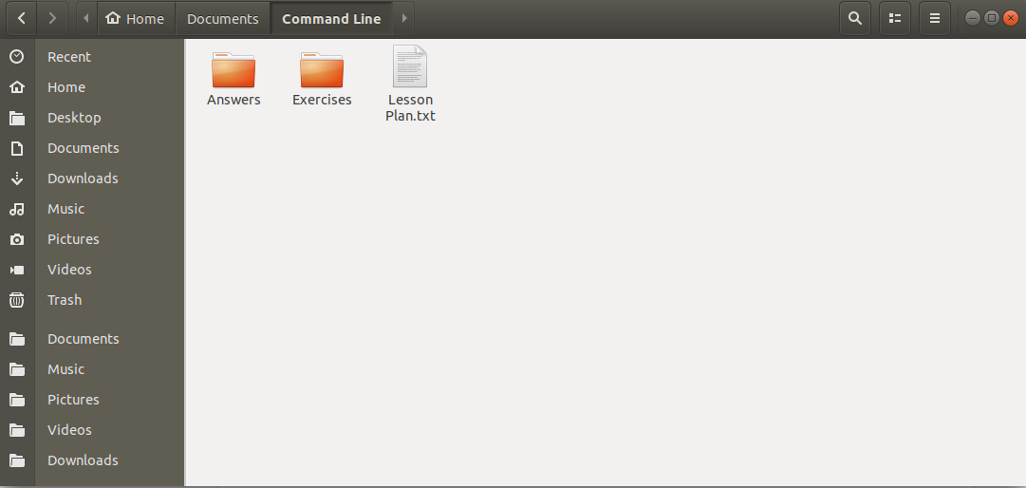

So first we need to figure out in which folder we are when we open the terminal. In Ubuntu the default is home (indicated with ~) So let’s open the terminal either by clicking the launch terminal icon or **CTRL+T** to launch it.

As you can see there is some text to the left. Something like **user@ComputerName:~$** Once you open your terminal it should look something like image B below.

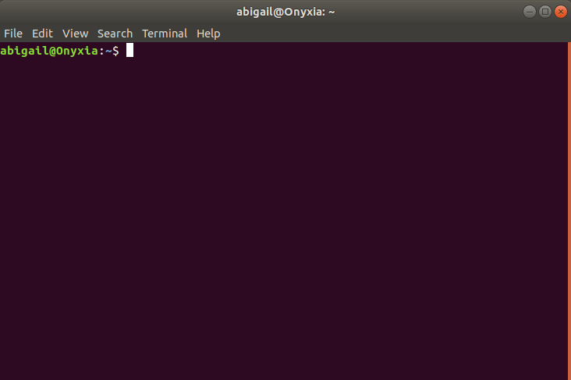

Now that we have it open let’s move around. If you use the GUI you would double click on a folder to navigate to it. In the terminal we need to use a command. The command to move is **cd** which stands for **c**hange **d**irectory. So let’s move to the desktop now. Input the following command:

**cd Desktop**

Have a look now at the location. It should be **user@ComputerName:~/Desktop$**. The command is broken down into two sections. The **command** and the **parameters**. The command **cd** accepts one parameter which is the path we want to go to. So we wanted to go to Desktop. Desktop is located under the home directory but since we were in it, we can simply just add the name of the folder. You are also able to add an explicit full path or navigate multiple levels down.

Example of an explicit path using ~ as a shortcut for home:

**cd ~/Desktop**

Example of an explicit path using the full path and not using ~ as a shortcut:

**cd /home/user/Desktop/**

Try these out even if you are in a different folder than home. They should take you to Desktop. (take note of where you are)

Now that we can navigate please follow Exercise 1 in addendum A. Once you are done you should feel free to check if you’ve successfully done it by looking at addendum B.

#### Common CLI commands

Below is a little cheat sheet of commands that are commonly used. For a full list of commands look at addendum C.

Protip: you can always use --help to get a help message. Example do **mkdir --help** or **cd --help**

|  |  |  |  |
| --- | --- | --- | --- |
| Command | Parameters | Example | Description |
| cd | Path you want to navigate to | cd ~/Desktop | This command allows you to navigate to any folder on the system by inputting the path to the folder. The example will navigate you to Desktop. |
| mkdir | Name of the directory and the path | mkdir ~/Documents/projects | This command allows you to make a folder. You can input just the name of the folder then it will create it in the current folder or you can add a path to it. The example will create a folder under Documents. |
| ls | Optional: path Optional: -a | ls ~/Desktop -a | This command allows you to view the files and folders inside a directory. Omitting a path will show the current folder, adding a path will show the contents of that folder, and added -a will show hidden files and folders. |
| cp | Target path to copy Destination path | cp ~/Documents/projects ~/Documents |  |

After studying the commands above here, try exercise 2 and 3!

It’s important to get a good grasp of the command line interface for your software development career.